Reg. No.20UCA501

**Ex. No.6**

Program to display Employee Details

**Program:**

<!doctype html>

<html>

<head>

<title>Employee Details</title>

</head>

<body>

<center><h2>Employee Details</h2></center>

<form action="#" method="post">

<table border="0" align="center" width="70%" cellpadding="10">

<tr>

<td width="50%" align="right">

Employee Name:

</td>

<td width="50%" align="left">

<input type="text" name="emp_nam" id="emp_nam" placeholder"Employee Name">

</td>

</tr>

<tr>

<td width="50%" align="right">

Date of Birth:

</td>

<td width="50%" align="left">

<input type="date" name="emp_dob" id="emp_dob"/>

</td>

</tr>

<tr>

<td width="50%" align="right">

Qualification:

</td>

<td width="50%" align="left">

<input type="text" name="emp_qua" id="emp_qua" placeholder"Employee Qualification"/>

</td>

</tr>

<tr>

<td width="50%" align="right">

Mail ID:

</td>

<td width="50%" align="left">

<input type="email" name="emp_ema" id="emp_ema" placeholder"Employee Mail Address"/>

</td>

</tr>

<tr>

<td width="50%" align="right">

Contact Number:

</td>

<td width="50%" align="left">

<input type="number" name="emp_mob" id="emp_mob" placeholder"Employee Mobile Number"/>

</td>

</tr>

<tr>

<td width="50%" align="right">

Address:

</td>

<td width="50%" align="left">

<textarea rows="5" cols="20" name="emp_add" id="emp_add"></textarea>

</td>

</tr>

<tr>

<td width="50%" align="right">

<input type="Submit" value="Submit" name="emp_sbt" id="emp_sbt"/>

</td>

<td width="50%" align="left">

<input type="Reset" value="Reset" name="emp_rst" id="emp_rst"/>

</td>

</tr>

</table>

</form>

<?php

if(isset($_REQUEST['emp_sbt']))

{

$emp_nam=addslashes($_REQUEST['emp_nam']);

$emp_dob=addslashes($_REQUEST['emp_dob']);

$emp_qua=addslashes($_REQUEST['emp_qua']);

$emp_ema=addslashes($_REQUEST['emp_ema']);

$emp_mob=addslashes($_REQUEST['emp_mob']);

$emp_add=addslashes($_REQUEST['emp_add']);

if($emp_nam==""||$emp_dob==""||$emp_qua==""||$emp_ema==""||$emp_mob==""||$emp_add=="")

{

echo"<script type=text/javascript>alret('Enter all fields!');</script>";

}

else

{

echo"<center>";

echo"Employee Name:<b>".$emp_nam."</b><br>";

echo"Date of Birht:<b>".$emp_dob."</b><br>";

echo"Qualification:<b>".$emp_qua."</b><br>";

echo"Email Address:<b>".$emp_ema."</b><br>";

echo"Mobile Number:<b>".$emp_mob."</b><br>";

echo"Address:<b>".$emp_add."</b><br>";

echo"</center>";

}

}

?>

</body>

<html>

**Output:**

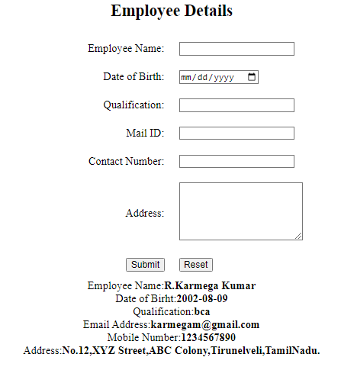

**Ex. No.7**

Program for Sorting N Numbers

**Program:**

<html>

<head>

<title>Sorting N numbers using array</title>

</head>

<body>

<center>

<h2>Sorting N numbers using array</h2>

<form action="#" method="post">

<b>Enter the values Array</b>:<textarea rows="5" cols="20" name="limit" id="limit"></textarea><br>

<br>

<input type="Submit" value="Get inputs" name="sbt_btn" id="sbt_btn">

</form>

<?php

if(isset($_REQUEST['sbt_btn']))

{

$limit=addslashes($_REQUEST['limit']);

if($limit==" ")

{

echo"<script type=text/javascript>alert('Enter the values for array!');</script>";

}

else{

$arrayvalues=preg_split('/\n/',$limit);

//Get and split the input values using new line

$arrayvalues=array_map('intval',$arrayvalues);

//Converting String values into integer inside the array

echo"The Given Input is:<br>";

foreach($arrayvalues as $val1)

{

echo $val1."<br>";

}

echo"<br>";

Sort($arrayvalues);//Sorting numbers using PHP Function

echo "The Sorted Input is:<br>";

foreach($arrayvalues as $val2)

{

echo $val2."<br>";

}

}

}

?>

</center>

</body>

</html>

**Output:**

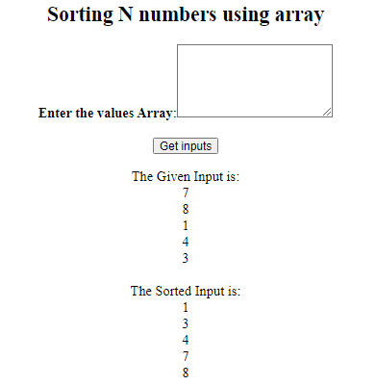

**Ex. No.8**

Program to display Student MarkList using Switch Statement

**Program:**

<!doctype html>

<html>

<head>

<title>Student Mark Statement</title>

</head>

<body>

<center>

<form action="#" method="post">

<br><br>

<h2>Student Mark Statement</h2>

Choose the Student:

<select name="stud" id="stud" required>

<option>Select One Name</option>

<option>Karthick</option>

<option>Akash</option>

<option>Vijay</option>

<option>Lakshmi</option>

<option>Pooja</option>

<option>Mirdhula</option>

</select>

<br><br>

<input type="submit" name="sbt_btn" id="sbt_btn" value="Get Info"/>

</form>

<br><br>

<?php

if(isset($_REQUEST['sbt_btn']))

{

$stud=addslashes($_REQUEST['stud']);

switch($stud)

{

case "Karthick":

echo"English:65<br>";

echo"Tamil:45<br>";

echo"Maths:67<br>";

echo"Social:87<br>";

echo"Science:89<br>";

break;

case "Akash":

echo"English:56<br>";

echo"Tamil:76<br>";

echo"Maths:87<br>";

echo"Social:54<br>";

echo"Science:56<br>";

break;

case "Vijay":

echo"English:66<br>";

echo"Tamil:47<br>";

echo"Maths:98<br>";

echo"Social:45<br>";

echo"Science:56<br>";

break;

case "Lakshmi":

echo"English:67<br>";

echo"Tamil:87<br>";

echo"Maths:65<br>";

echo"Social:67<br>";

echo"Science:87<br>";

break;

case "Pooja":

echo"English:98<br>";

echo"Tamil:67<br>";

echo"Maths:78<br>";

echo"Social:89<br>";

echo"Science:78<br>";

break;

case "Mirdhula":

echo"English:67<br>";

echo"Tamil:87<br>";

echo"Maths:55<br>";

echo"Social:76<br>";

echo"Science:78<br>";

break;

default:

echo"No Records Found!";

}

}

?>

</center>

</body>

</html>

**Output:**

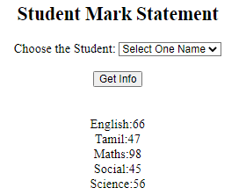

**Ex. No.9**

Program to Create and Write File

**Program:**

<!doctype html>

<html>

<head>

<meta charset="utf-8">

<title>File Create and open using PHP</title>

</head>

<body>

<?php

$myfile=fopen("newfile.txt","w")or die("Unable to open file!");

$txt="I am Karmega Kumar.\n";

fwrite($myfile,$txt);

$txt="I am from the department of BCA.\n";

fwrite($myfile,$txt);

fclose($myfile);

echo"<center><h2>File Created!Kindly check the Location!</h2></center>";

?>

</body>

</html>

**Output:**

**File Created!Kindly check the Location!**

**newfile.txt**

I am Karmega Kumar.

I am from the department of BCA.

**Ex. No.10**

Program to Open and Read File

**Program:**

<!doctype html>

<html>

<head>

<meta charset="utf-8">

<title>File Open and Read using PHP</title>

</head>

<body>

<?php

$myfile=fopen("newfile.txt","r")or die("Unable to open file!");

echo fread($myfile,filesize("newfile.txt"));

fclose($myfile);

?>

</body>

</html>

**Output:**

I am Karmega Kumar. I am from the department of BCA.

**Ex. No.11**

Program for uploading a file

**Program:**

<!doctype html>

<html>

<head>

<meta charset="utf-8">

<title>File Uploading</title>

</head>

<body>

<center>

<h3>File Uploading</h3>

<form action="#" method="post" enctype="multipart/form-data">

<label>Choose your file:</label>&nbsp;&nbsp;&nbsp;&nbsp;

<input type="file" name="up_file" id="up_file" required>

<br><br>

<input type="submit" value="Upload" name="btn_sbt" id="btn_sbt"/>&nbsp;&nbsp;&nbsp;&nbsp;

<input type="reset" value="Cancel" name="btn_rst" id="btn_rst"/>

</form>

</center>

<?php

if(isset($_REQUEST['btn_sbt']))

{

$location="Upload";

$up_file_name=addslashes($_FILES['up_file']['name']);

if((move_uploaded_file($_FILES["up_file"]["tmp_name"],$location.$up_file_name)))

{

echo"<script type=text/javascript>alert('File Uploaded Succesfully!');window.location.assign('file_upload.php');</script>";

}

else

{

echo"<script type=text/javascript>alert('Error in Upload!Try Again!');window.location.assign('file_upload.php');</script>";

}

}

?>

</body>

</html>

**Output:**

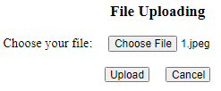

File Uploaded Successfully!

**Ex. No.12**

Program for sending a mail

**Program:**

<!doctype html>

<html>

<head>

<meta charset="utf-8">

<title>Sending Mail</title>

</head>

<body>

<center>

<h3>Sending Mail</h3>

<form action="#" method="post" enctype="multipart/form-data">

<label>Your Name:</label>&nbsp;&nbsp;&nbsp;&nbsp;

<input type="text" name="yr_nam" id="yr_nam" required">

<br><br>

<label>Your No:</label>&nbsp;&nbsp;&nbsp;&nbsp;

<input type="number" name="yr_num" id="yr_num" required">

<br><br>

<label>Your Message:</label>&nbsp;&nbsp;&nbsp;&nbsp;

<textarea name="yr_msg" id="yr_msg" required></textarea>

<br><br>

<input type="submit" value="Send" name="btn_sbt" id="btn_sbt"/>&nbsp;&nbsp;&nbsp;&nbsp;

<input type="reset" value="Cancel" name="btn_rst" id="btn_rst"/>

</form>

</center>

<?php

if(isset($_REQUEST['btn_sbt']))

{

$yr_nam=addslashes($_REQUEST['yr_nam']);

$yr_num=addslashes($_REQUEST['yr_num']);

$yr_msg=addslashes($_REQUEST['yr_msg']);

$from="sender@mail.com";

$to="receiver@mail.com";

$subject="Mail sending from My Website";

$message="Sender Name:".$yr_nam."\n\n Subject:".$subject."\n\nFeedback Message:".$yr_msg."\n\n";$headers="From:".$from;

$headers="From:".$from;

mail($to,$subject,$message,$headers);

echo"<script type=text/javascript>alert('Your Feedback has been sent Succesfully');window.location.assign('mail_send.php');</script>";

}

?>

</body>

</html>

**Output:**

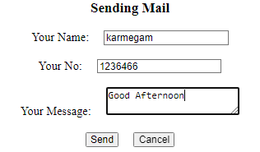

Your Feedback has been sent Successfully